骰子

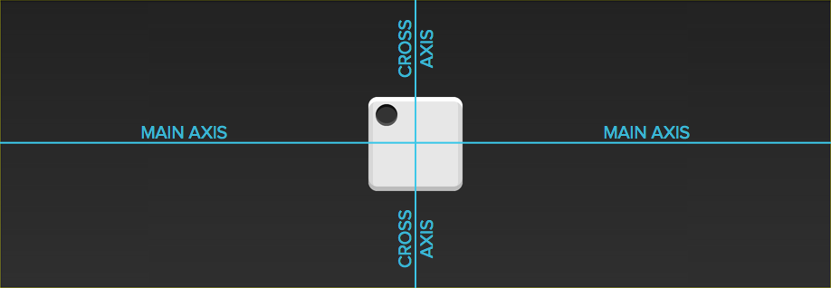

如果不加说明，本节的HTML模板一律如下。

<div class="box">

<span class="item"></span>

</div>

上面代码中，div元素（代表骰子的一个面）是Flex容器，span元素（代表一个点）是Flex项目。

如果有多个项目，就要添加多个span元素，以此类推。

2.1.1 一个点

首先，只有左上角1个点的情况。Flex布局默认就是首行左对齐，所以一行代码就够了。

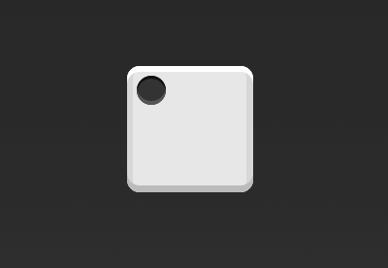

.box {

display: flex;

}

设置项目的对齐方式，就能实现居中对齐和右对齐。

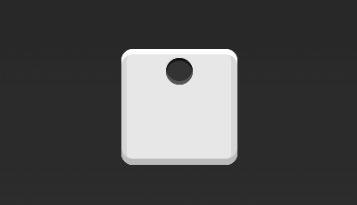

.box {

display: flex;

justify-content: center;

}

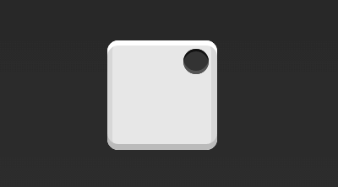

.box {

display: flex;

justify-content: flex-end;

}

设置交叉轴对齐方式，可以垂直移动主轴。

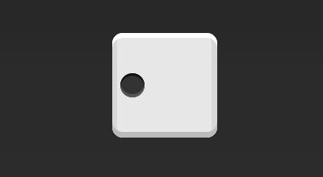

.box {

display: flex;

align-items: center;

}

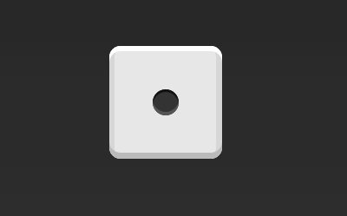

.box {

display: flex;

align-items: center;

}



.box {

display: flex;

justify-content: center;

align-items: center;

}

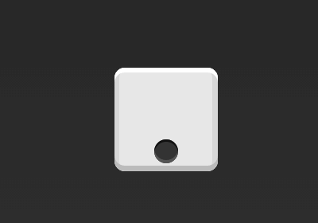

.box {

display: flex;

justify-content: center;

align-items: flex-end;

}

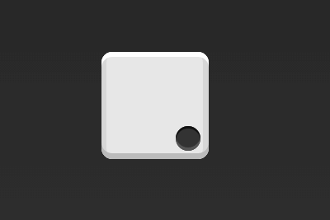

.box {

display: flex;

justify-content: flex-end;

align-items: flex-end;

}

2.1.2 两个点

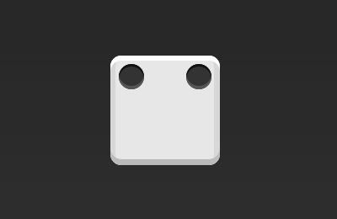

.box {

display: flex;

justify-content: space-between;

}

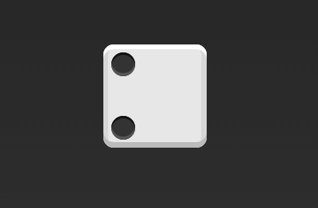

.box {

display: flex;

flex-direction: column;

justify-content: space-between;

}

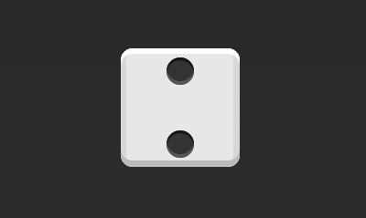

.box {

display: flex;

flex-direction: column;

justify-content: space-between;

align-items: center;

}

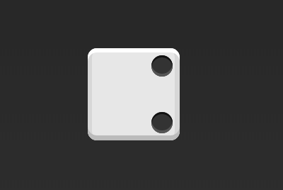

.box {

display: flex;

flex-direction: column;

justify-content: space-between;

align-items: flex-end;

}

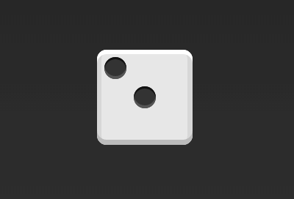

.box {

display: flex;

}

.item:nth-child(2) {

align-self: center;

}

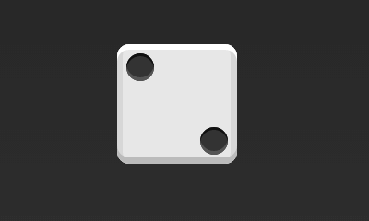

.box {

display: flex;

justify-content: space-between;

}

.item:nth-child(2) {

align-self: flex-end;

}

2.1.3 三个点

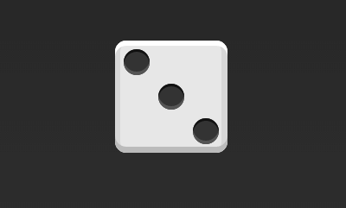

.box {

display: flex;

}

.item:nth-child(2) {

align-self: center;

}

.item:nth-child(3) {

align-self: flex-end;

}

2.1.4 四个点

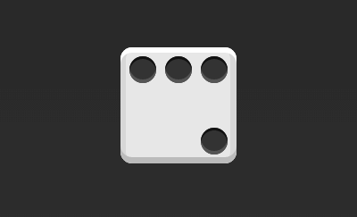

.box {

display: flex;

flex-wrap: wrap;

justify-content: flex-end;

align-content: space-between;

}

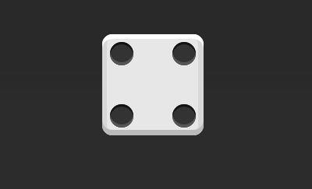

HTML代码如下。

<div class="box">

<div class="column">

<span class="item"></span>

<span class="item"></span>

</div>

<div class="column">

<span class="item"></span>

<span class="item"></span>

</div>

</div>

CSS代码如下。

.box {

display: flex;

justify-content: space-between;

}

.box .column {

display: flex;

flex-direction: column;

justify-content: space-between;

}

2.1.5 六个点

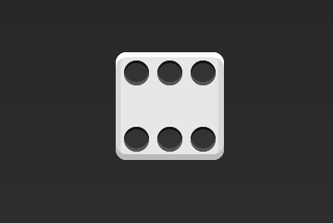

.box {

display: flex;

flex-wrap: wrap;

align-content: space-between;

}

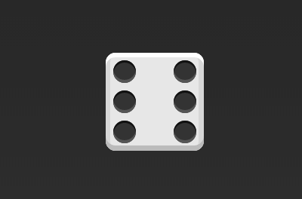

.box {

display: flex;

flex-direction: column;

flex-wrap: wrap;

align-content: space-between;

}

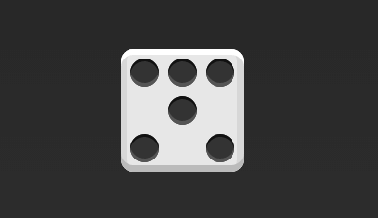

HTML代码如下。

<div class="box">

<div class="row">

<span class="item"></span>

<span class="item"></span>

<span class="item"></span>

</div>

<div class="row">

<span class="item"></span>

</div>

<div class="row">

<span class="item"></span>

<span class="item"></span>

</div>

</div>

CSS代码如下。

.box {

display: flex;

flex-wrap: wrap;

}

.row{

flex-basis: 100%;

display:flex;

}

.row:nth-child(2){

justify-content: center;

}

.row:nth-child(3){

justify-content: space-between;

}

2.1.6 九个点

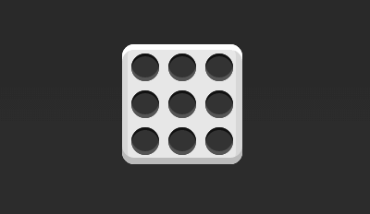

.box {

display: flex;

flex-wrap: wrap;

}